

YOUTH BOWLING SCHOOL
APPLICATION

Name _________________________________________________

Address _______________________________________________

City ___________________________________________________

Postal Code ____________________________________________

Telephone ____________________ Age _____________________

Male _________________ Female __________________________

Average ______________ Bowling Centre ____________________

T-Shirt Size(Unisex) ____________

Email __________________________________________

Been to Bowling School Before? Yes _____ How Many _____ No _____

Further questions may be directed to:

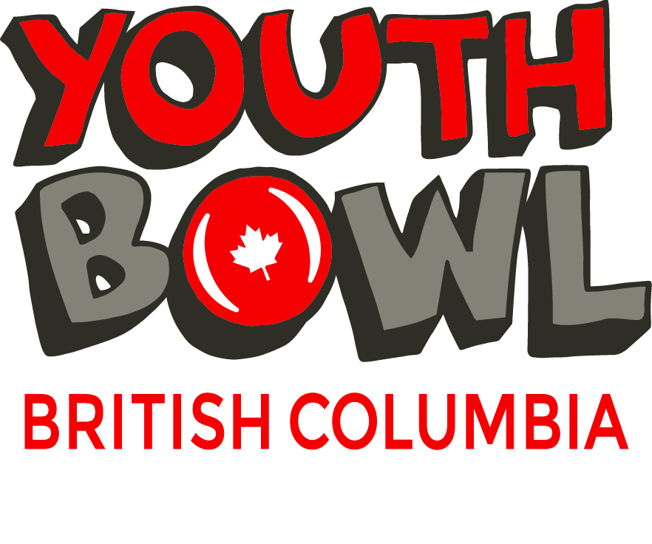
9345 Robson Road
Prince George, BC, V2N 5B5
(250) 964-2648
Email: bowl4fun@bowlbc.com

** Mail to the above address or email in PDF form.
** E-transfer: feepayments@bowlbc.com

